1. We got this error right after we made the new authorized callback

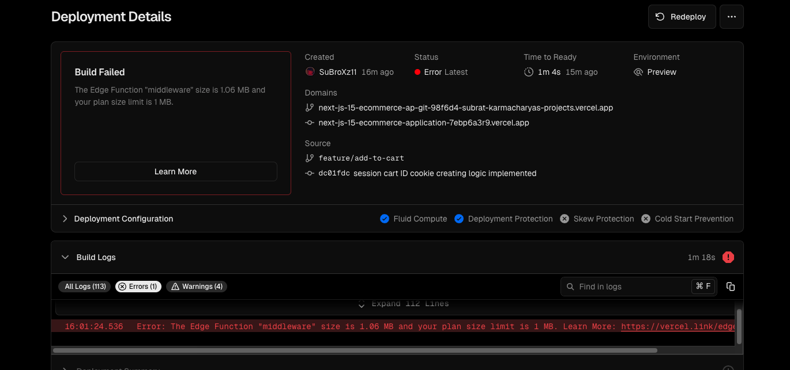

As our next js runs on edge runtime and our free tier has limitations due to its lightweight environment

1. To fix this we made a new file in our root and cut pasted the authorized par and the next auth config to divide the files and make space

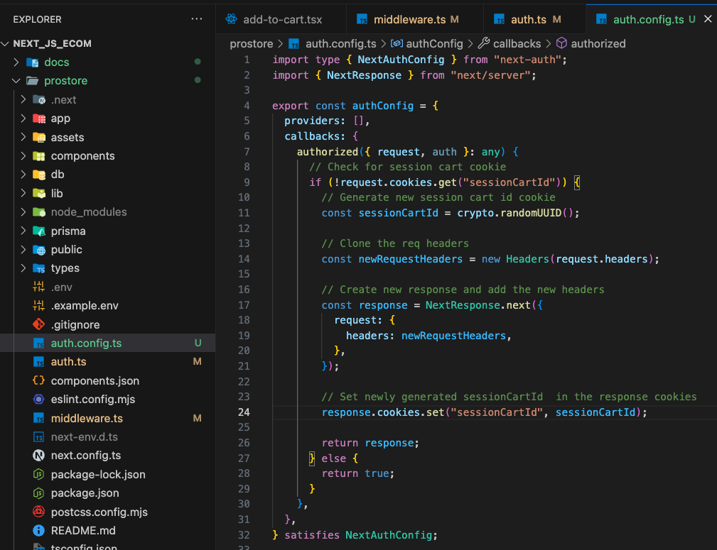

1. Then we imported that in our auth



* Used it in the callbacks using spread operator

* Then set the type of JWT as constant to remove the typescript error we were getting

1. Finally updated the middleware file

* And everything works just fine